**SUMMARY**

CONTRIBUTIONS AND RESULTS FROM RELATED WORKS:

The results are divided into 4 parts:

1. Incentive mechanism design with multi-dimensional private information: The description of how the incentive is provided to each user considering their private information and this model has also considered different levels of information asymmetry.
2. 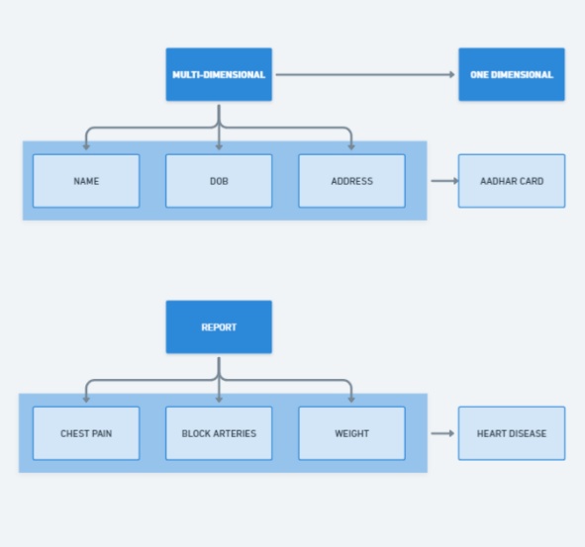Multi-dimensional contract and server preference characterization: Finding the optimal solution is challenging due to the incomplete information that is provided to the model in FL. In this they have summarize the user’s multi-dimensional private information with a single dimension.  
   Eg: If we have the data of a user 1; DOB, Address and their name this is the user’s multi-dimensional private information but we can summarize this to that user’s Aadhar Card which is a single dimension private information of that user.
3. Investigation on effect of multiple information asymmetry levels: This revels the influence of information asymmetry on gaining the optimal solution. Complexity increases with information incompleteness. The authors have taken the case when the users have IID (Independent and Identical Distribution) data. They have two scenarios here:
4. 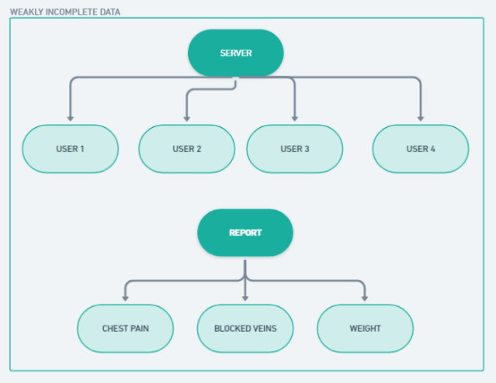Weakly Incomplete Data: The data that describes the different number of users. This type data does not increase the server’s cost. Server will have a higher cost compares to complete information scenario as the server may be more than one type of users to avoid non-IID data.

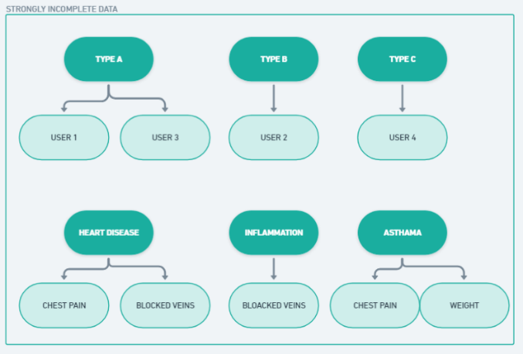

1. Strongly Incomplete Data: The data that describes the user type distribution. This type of data increases the server’s cost. This type of data is ont optimal for the server even when we choose useres with lowest training cost and delay.
2. Evaluation on accuracy loss given non-IID data: The authors have characterized the non-IID degree of users’ data through the Earth Mover’s Distance (EMD). EMD is the distance between the probability distribution over a region. They have further done a numerical analysis using the CIFAR-10 dataset. CIFAR-10 dataset contains images for object recognition with 60,000 images and 10 classes. The analysis results in the given non-IID data and has a stable loss co-efficient than that of the randomly generated IID data. From this we can conclude that IID case can be converted to the non-IID case by introducing a loss coefficient.

FEDERATED LEARNING PROCESS

In this section the authors explain how federated learning works. The users train on their local data and combine predictions, send it to the server and repeat the process to cooperatively train a global learning model. The user only shares the model parameter with the server and not the raw data.

The FL models are normally being applied to the timely traffic flow prediction. The traffic flow prediction is the estimate of the flow count at a future time based on the data collected from the previous periods.

The authors have used this approach and have applied Synchronous FL algorithm to test how the model parameters are updated. This algorithm takes the iterations, learning rate, number of users and their data to provide the model parameter. The server sends the global parameters to all the users at that same time, each user computes the local parameter and sends it back to the server and when all the users have finished their execution the server aggregates all the users’ updates to update the global parameter.

USER TYPES

The author has distinguished the users by two-dimensional private information:

1. Marginal Data Usage Cost (theta) 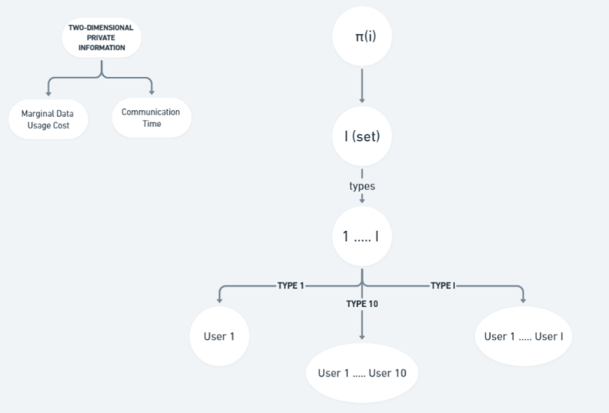
2. Communication time (t)

CONTRACT FORMUALTION

The authors have used the contract theoretic framework to tackle the incentive mechanism design problem.

1. Server’s contract: The server proposes a contract to the users. The contract (C) has maximum communication time and I contract items. t max updates every global round. If t(i) < t max then the users have finished the transmission of the parameters in time. If the user completes the training task in required time and data size, then the server offers it with a reward (r). The server offers a zero contract item for any user with t(i) > t max.
2. User’s choice: The user has the choice whether to join the training or not. If they decide to join then the user also has to choose a contract item. The users don’t participate of their payoff is negative. (If the payoff is negative then they are not getting the reward or the reward is negative)

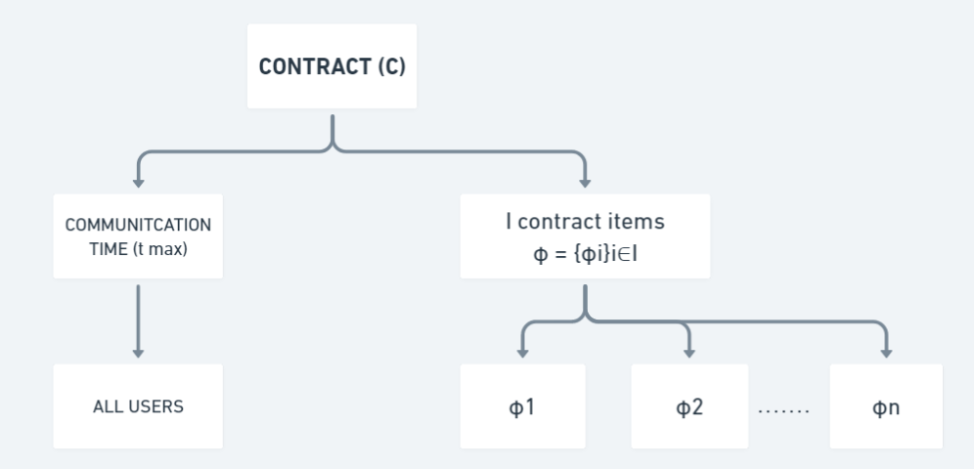 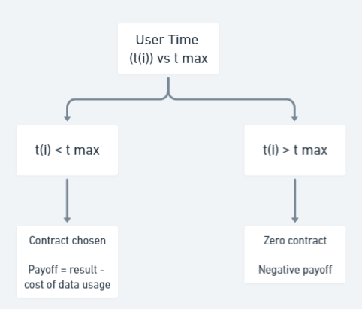

USER’S PAYOFF

Each user’s payoff in each global round is the difference between the reward offered by the server and the cost of data usage in model training. The authors have assumed that the training cost is proportional to the used data size. They have also assumed that in each global iteration each user performs one step of mini-batch stochastic gradient descent to compute the model parameter.

Users with t(i) < t max are only allowed to train the model because the centralized mini-batch SGD will zero in the other case.

SERVER’S COST (W)

With a fixed training time, the server’s cost is determined by the accuracy loss of global model and the total payment to users.

The accuracy loss after (D) global iterations will be determined by the difference between the prediction loss with parameter (w) and the optimal parameter(w*). Here each user uses the mini-batch SGD and have IID data. Due to this the server’s loss in accuracy decreases the number of iterations and batch size increases.

Total Payment is calculated as the product of no. of global iteration and the payment to all users in each iteration.

The server’s cost (W) = Accuracy loss of the global model + Total Payment

MULTI-DIMENSIONAL CONTRACT DESIGN FOR USERES WITH IID DATA

The authors have divided the impact of incomplete information into 3 information scenarios:

1. Complete Information Scenario: The server knows all the user’s private information which includes each user’s type.
2. 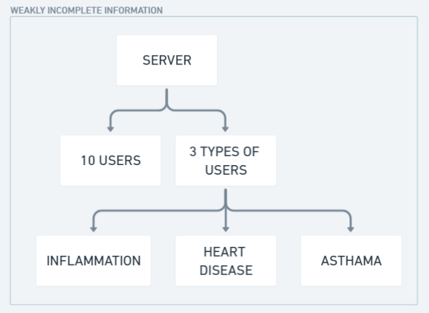Weakly Incomplete Information Scenario: The server knows the total number of users and the specific number of each type of user but it doesn’t know which user belongs to which type.
3. 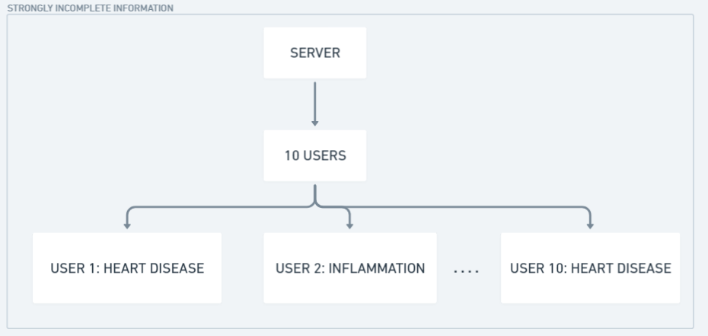Strongly Incomplete Information Scenario: The server only knows the total number users and the types of user distribution; it does not know the specific number of each user type.

**Contract Feasibility**: A contract is feasible if each user achieves maximum payoff under contract item designed for his type.  
Eg: If user1 chooses heart disease and has heart disease then it will maximum payoff thus this contract will be feasible.

**Contract Optimality**: A contract is optimal if it minimizes the server’s cost among all feasible contracts.  
Eg: If all the users choose their contract and it gives maximum payoff then the condition of contract optimality is achieved.

**Individual Rationality**: A contract is individually rational if each type-I user receives a non-negative payoff by accepting the contract items intended for his type.  
Eg: If user1 chooses heart disease but it does not have heart disease but has some symptoms of heart disease which is included in the user type that will not give the user the maximum payoff but will also not give a negative payoff.

**Preference**: The server has a higher preference on jth type than ith type if and only if the server’s cost of choosing j is less than that of i.

**Incentive Compatibility:** A contract is incentive compatible if each type-i user maximizes his own payoff by choosing the contract item intended for his type.  
Eg: If a user chooses heart disease type and it knows that it has heart disease then it will yield the maximum payoff.

In Complete Information Scenario, a contract is feasible if and only if it satisfies the Individual Rationality constraints i.e the payoff (U) > 0. In this scenario the authors have derives the server’s optimal reward and then used that optimal reward to find the optimal data size and the optimal maximum communication time. The authors have used Theorem 1 in this scenario. Theorem 1 states that that server will only provide a positive contract to the most preferred user and zero contract to all the other users. The incentive system under the complete information scenario maximizes the social welfare. This is because the server is choosing the most preferred item from the preference set.

In Weakly Incomplete Information Scenario, the server designs a contract that ensure the Incentive Compatibility constraints i.e payoff for ith user > payoff for jth user if ith user has chosen the contract item which was intended for them. In this scenario the authors have transformed the individual rationality and incentive compatibility constraint into smaller number of equivalent constraints. After applying these conditions, the optimal reward, optimal data size and optimal communication time is derived. In this scenario, a contract is feasible if the payoff is non-negative, the server should request for more data from a user if their marginal cost is low and in exchange provide more reward. In this scenario, the server knows the number of each user type, thus the server can focus on designing a contract for the most preferred user, this will provide us with the same minimum cost as the complete information scenario.

In Strongly Incomplete Information Scenario, since the server only knows the number of users and their distribution types, due to uncertainty the server will have to minimize the expected cost. To solve this the server will have to design a new contract, it cannot use the contracts designed in the previous scenarios even though the minimum cost from both the scenarios were same, in this case a new contract will be created as here probability of a user being a certain type is also being calculated. The authors have used a Two-Part Uniform (TPU) Contract structure to solve the cases in this scenario. This contract has two types of contract items, positive for a certain group of user types and zero for the rest of users.

If the server chooses to adopt the optimal TPU contract, the it will have a bounded cost difference as compared with the previous scenarios.   
A proposition is put up by the authors that states that when we have a large number of users the server will only set a positive contract item for most preferred type and that will result in a zero cost gap. Choosing some users with lower preferences may minimize the server’s cost.  
Another proposition states that an optimal TPU contract will only exist if user type i belongs to the optimal set and user type j does not belong to the optimal set and the cost of choosing i is higher than that of j. Under this proposition selecting a user with higher preference will not provide us with the optimal solution if the existence probability of that user is small. The server’s cost is also determined by the maximum communication cost and the maximum marginal cost. Due to these, choosing a user with high preference will not provide us with a good performance the server’s cost will be higher if the server chooses a high preference user and this will also not provide with the best optimal solution.